Stat Min Instructions

TEA released the 2019-2020 for the State Minimum Salary Schedule for classroom teachers, full-time librarians, full-time counselors, and full-time registered nurses on Tuesday, June 11th. In addition to these instructions we are sending 2 files:

- A pdf of the 2019-2020 Minimum Salary Schedule compared to the 2018-2019 Minimum Salary Schedule, as Salary schedule, as published by TEA.
- A file to load into the TxEIS software. Download this file and save for use on Step 2.
- These will also be on our Web site.
According to House Bill 3, the 2019-2020 Stat Min table will go into effect on 9/1/2019 and the TRS Cost Education Index (CEI) will be removed from those calculations. For budgeting purposes, the new Stat Min table needs to be loaded into the Next Year Payroll frequency and the CEI will need to be monitored.
Note: Current State Min calculations use the CEI rate (unique for each district) for TRS reporting purposes. The CEI is located on the HR > Tables > District HR Option. The CEI is a shared field, utilized in both Current and Next Year Payroll.
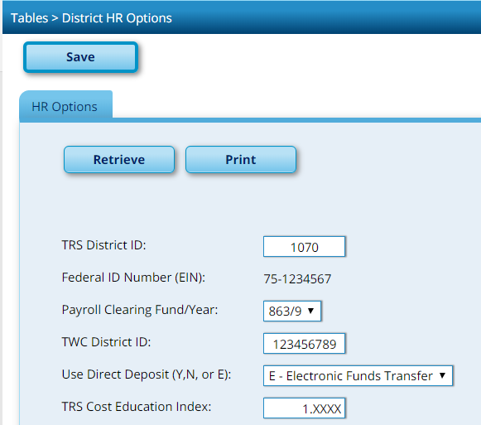
CEI is District Specific

Since the CEI is a shared field between Current Payroll and Next Year Payroll, changing the CEI will need to be monitored very closely. Communication and timing will be key between the Budget and HR staff performing these duties.
The CEI is used in Current Payroll in the monthly adjusted state minimum salary calculations for TRS Stat Min Contributions and Non-OASDI contributions. As TRS extracts are performed for TRS processing for June, July and August, the CEI needs to remain populated at the current (unique) rate for your district. This is for all TRS processing through August, regardless of when your fiscal year ends or when your salaries change for the first payroll of the school year.
In Next Year Payroll, for Budgeting purposes, we need to install the new 2019-2020 Stat Min schedule and amend the CEI. For correct State Minimum calculations, the TRS CEI field must be set to 1.0 for the 2019-2020 year (but must be reverted to its original value for TRS processing for current year).
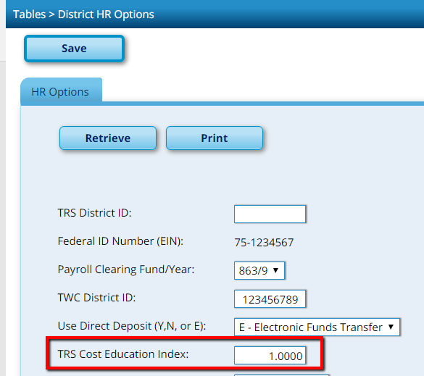
Note original CEI so you can change it back in CYR payroll after updating Budget.

We recommend creating an export of your Current and Next Year Payrolls before loading the new Stat Min table.
- Human Resources > Utilities > Export Human Resources by Payroll
• Create a backup of both CYR and NYR frequencies (example 6 and F)

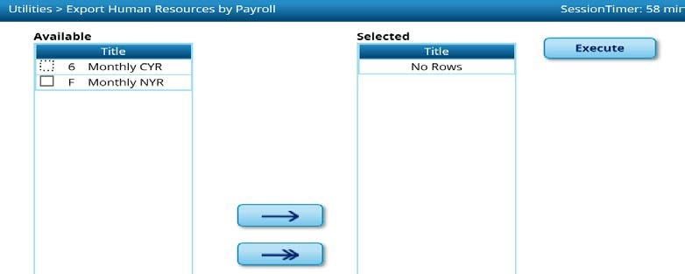

- In Human Resources, verify that you are in Next Year. Click on Utilities > Install Salary/Tax Tables

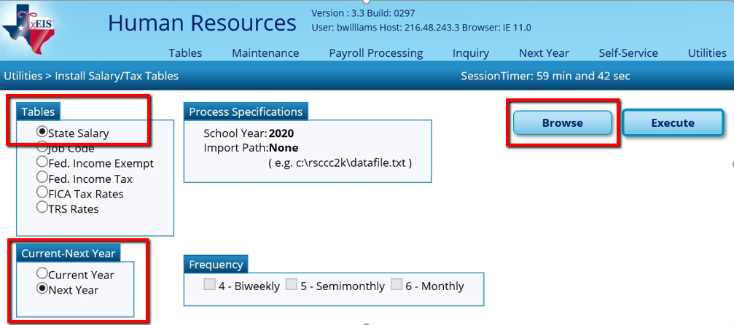

Select State Salary under Tables. Select Next Year under Current-Next Year Click Browse.

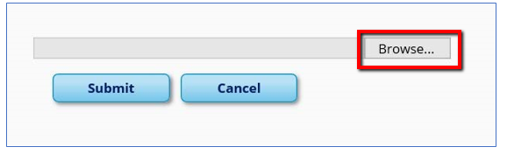

Click Browse (again). Find the StatMin_2019-2020 files, saved from this email or our website.
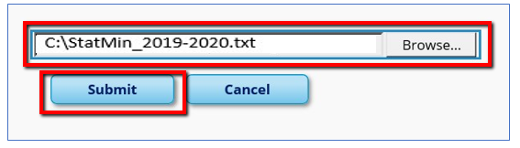
Click Submit
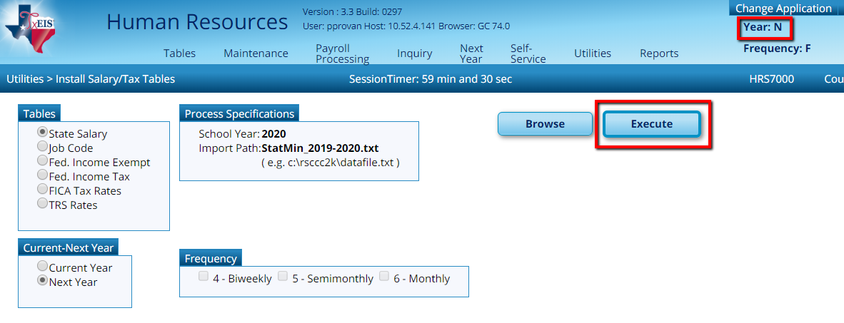
Click Execute.
A report will display:

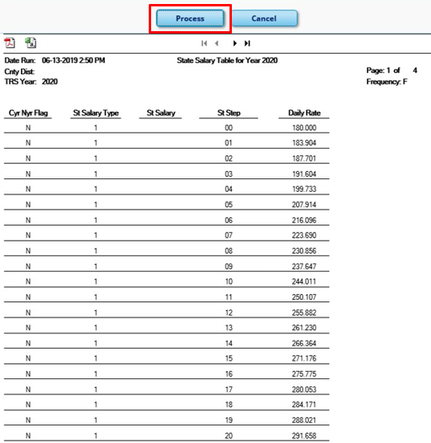
Click Process.
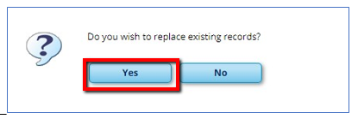
Click Yes

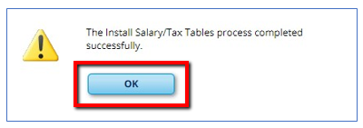
Click OK.

Note: It is possible TRS will make changes to minimums used on Administrators. If they do, the TCC will issue an updated Stat Min table to upload. Region 14 will communicate the change and send additional instructions as needed.

3. Verify table updated correctly.
In Human Resources NEXT YEAR > Tables > Salaries NYR > State Min tab, your screen should look like:

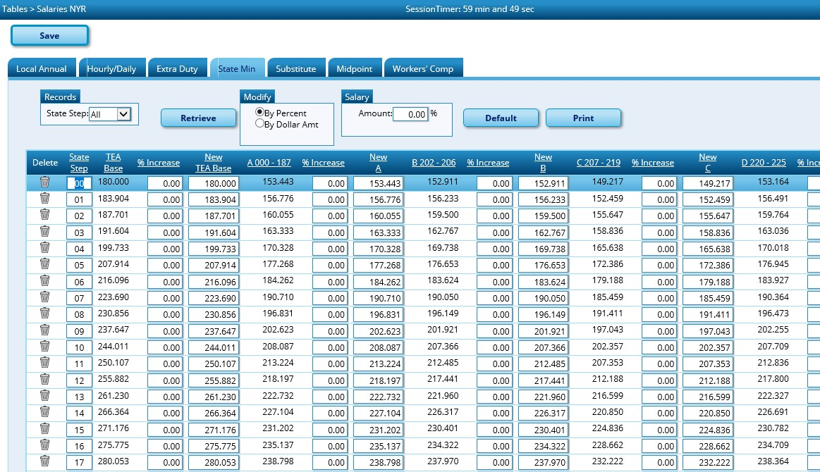

- If you use salary schedules, please amend the tables for your teachers. Enter your changes in the Local Annual. If still in doubt as to what salaries the district is going to proceed with, at least increment these to match the 2019-2020 Stat Min schedule.

In HR > Tables > Salaries NYR > Local Annual

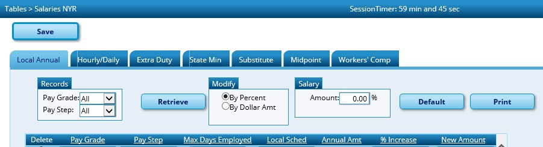

- If salaries have changed, salaries will need to be recalculated. In HR > Utilities > Mass Update > Salary Calculation tab. Select Salary and Click Execute.

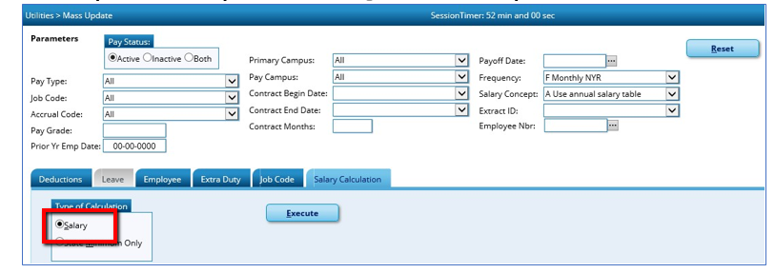

- Stat Min salaries will need to be recalculated. In HR > Utilities > Mass Update > Salary Calculation tab. Select State Minimum Only and Click Execute.

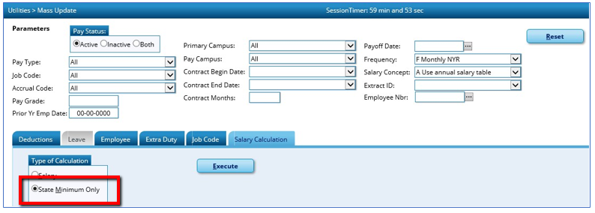
- WARNING!!!!! Communication and timing is very important between HR and Budgeting staff.

In Next Year Payroll, for Budgeting purposes only, the TRS CEI field must be set to
1.0 for the 2019-2020 year (but must later be reverted to its original value of
1.XXXX for TRS processing for current year). In HR > Tables > District HR Options

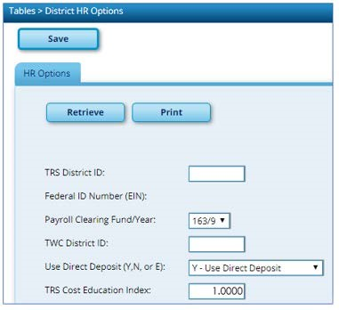

Verify that the CEI is set to 1.0000 before performing a new “Extract Payroll Account Codes”

- In Next Year Payroll > Next Year Tab > Interface NY Payroll for NY Budget

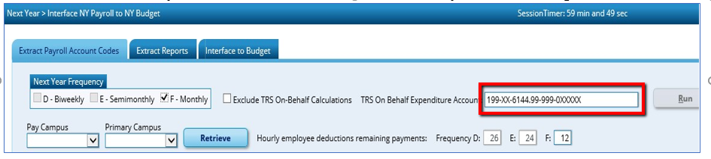
Enter account used during Payroll.
Perform the Extract Payroll Account Codes, verify Reports, and Interface to Budget.

- As soon as possible, reset the CEI back to its original value. This has to be the original value for all TRS extract processing through August.
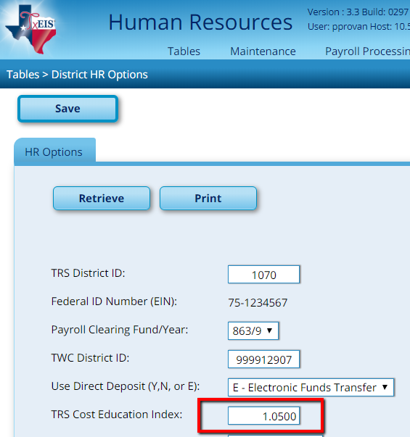
CEI is District Specific

Warnings:
- Be very careful and mindful of the Shared CEI rate.
- If you load the new Stat Min table and leave the CEI at the existing rate (anything over 1.0) in Next Year, your Stat Min will be under-estimated for your NYPR Budget.
- If you leave the CEI at the 1.0 that is necessary for NYPR and run the TRS extract in Current Payroll, the TRS Stat Min calculations will be incorrect on your TRS reports.
- If you calculate Stat Min on the older Stat Min rates, you will over-budget for the Stat Min, since Stat Min salaries have increased greatly.

